**Pointers to fill the Application form:**

1. Click on “Fill and sign” option available on the right panel of pdf.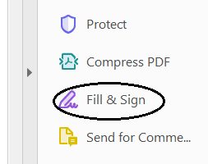
2. Start filling the form and save. To adjust the font size keep clicking on A or A as shown below:

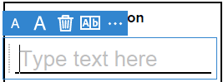

1. Place the cursor on the **box provided to** **paste the photograph** and click on **Sign** icon available on top panel,  which will give an option to upload the document. Click on **Add Initials**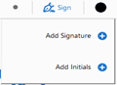 then **image** (it will open the browser to upload). **Please upload your latest photograph.**
2. Similarly, place the cursor **near signature on Page 3** and click on **Sign** icon again, then click on **Add Signature**  and then **image** (it will open to browser to upload). You can also draw your signature. But its recommended to take the picture of your signature and then upload.